

INFS3202

*Web Information System*

# Group Proposal

## Project

## Wedding Stylish

### Team Members

|  |  |  |
| --- | --- | --- |
| **Student ID** | **Name** | **Enrolled Prac Session** |
| 44450672 | Yaxin Cui | T02 |
| 44109073 | Chen Liu | T03 |
| 44185282 | Liqun Zeng | T09 |

## Project overview

We are going to use database, SQL, PHP and Javascript to design and develop a wedding dress selling website. Customers can visit and buy the wedding dress through the website, and share their experience with other customers.

## Use Cases

The wedding dress selling website will contain several features, the front-end of the website will mainly use HTML, and the back-end will use PHP, JavaScript or other languages.

### Sign in

The basic function is the form validation which people can sign in or register as a new user. There are three different kinds of users which are normal user, designer and administrator, however, people can only register as a normal user or designer through the register page. Administrator can view, delete, edit, update and post any information on the website.

On the top right on the homepage, there will be a sign- in/sign-up button. For example, a client clicks sign up button, the website will go to the sign-up page. Next, client have to input the personal information by requirement. By click the ‘sign-up’ button (which on the bottom of the page), the username will be check by the system’s database in order to make sure it is unique. After than system ‘s database will store user’s information. When all the sign-up steps are successful, the page will return to the homepage and automatically sign in with the account that the user just registers. (Register as a designer requires to upload files with at least one wedding design and it need to be verify.) However, the sign in part is different from the sign-up part. Users only need to insert their username and password, after checking the correctness of account and password by searching the database though the system. Once it is successful, website will return to the homepage, and at the top right corner, it will display the user’s name which instead of the sign-in/sign-up button (user’s name is different as username, the username is made up by users with numbers and letters, user’s name is the name of the user).

### Place Order

As a shopping website, shopping cart and view orders are important functions for users. Once the ‘buy’ button is clicked on the commodity page, the good will be added automatically to the shopping cart. Clients can delete or edit the quantity of the good in the shopping cart page. If clients click the ‘purchase’ button, it will display the payment page.

After a successful payment, the system will receive the order and sent to the seller (in this case, the seller will be us). Users will be inform that the payment is all done and they can go to their own profile page by clicking their user’s name (on the top right of the page), view their orders and check the delivery information. Clients who did not register will receive an order code after purchasing goods so that they can check the information of the order as well.

### BBS

BBS (Bulletin Board System) is another special function on our website. Normal users can have customized product by post their demand, request and reward on BBS, and designer can accept a customized order from other users. Also, designers can upload and share their own wedding dress design on BBS, other users can discuss on the post page or click ‘like’ button. To make sure all designs that show on the website are superior quality, register as a designer needs to be verified by the administrator. There will be a ‘Share and Discover’ button on the top left of the page that jumps to BBS page, all clients can go to this page, however, only users can post messages. On BBS pages, administrators can view, delete, update and post any information on the BBS.

Communication Topology of the System

Tip: Bold means the information being sent through different layers. Underline means the direction between the 3-tier architecture hierarchies.

### 1. User register:

There is a signup page link on the homepage. In the sign-up page, users must fill all user information (like account name, password, birthdate, etc.) in a provided form and submit it. After submission, all generated user information will be sent by the browser to the server (from Presentation layer to Business layer). The server will operate corresponding code to check the availability (uniqueness of account name). Once the information is acceptable, server store the user information in an account database (from Business layer to data access layer) and send a response (sign up successful page) to the client (from Business layer to Presentation layer).

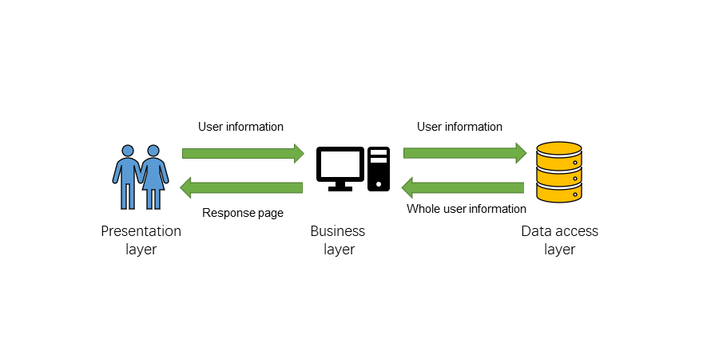

### 

### 2. Purchase:

Users can purchase the wedding dress via the website. Every product will have buy button with a unique id in the HTML page. The browser will send the product id and user identification（account name） to web server (from Presentation layer to Business layer) when the client clicks purchase button. The server will run the specific code to process the product information (check the inventory and generate an order number) (from Data access layer to Business layer). If the processing is successful, the server will save the product id, order number and account name in a purchase database (from Business layer to Data access layer) and send the order number to the client (from Business layer to Presentation layer).

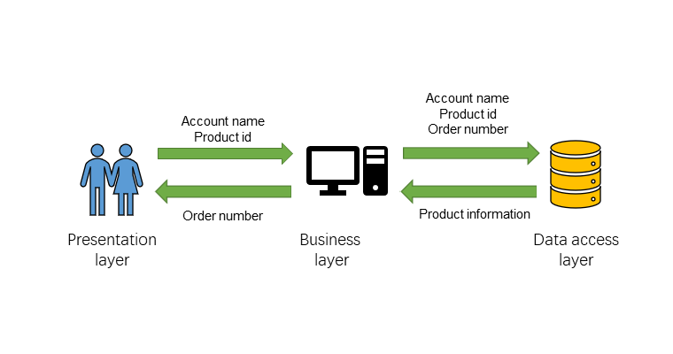

### 3. Order process view:

An order list page will be presented to clients if they want to inspect their orders. Once client turn into the order list page, client browser will send the request with account name to web server (from Presentation layer to Business layer). After that, Server operates programming code to search and generate order list from purchase database (from Data access layer to Business layer). Then the server will send the order list information to client web browser to represent (from Business layer to Presentation layer).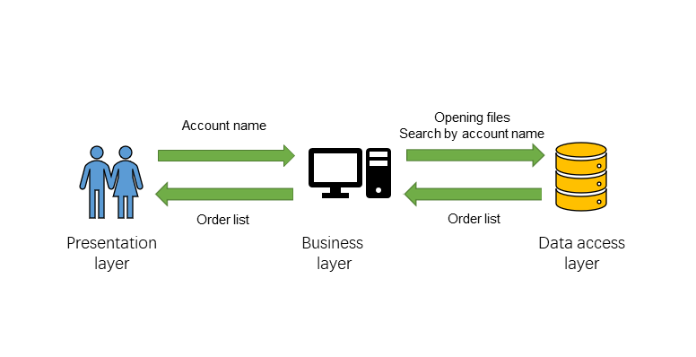

Design Mock-up

Main page: Basically, our navigation has about us, look page for dress design, BBS, shopping cart and login. Once the user login, their username will instead of the login.

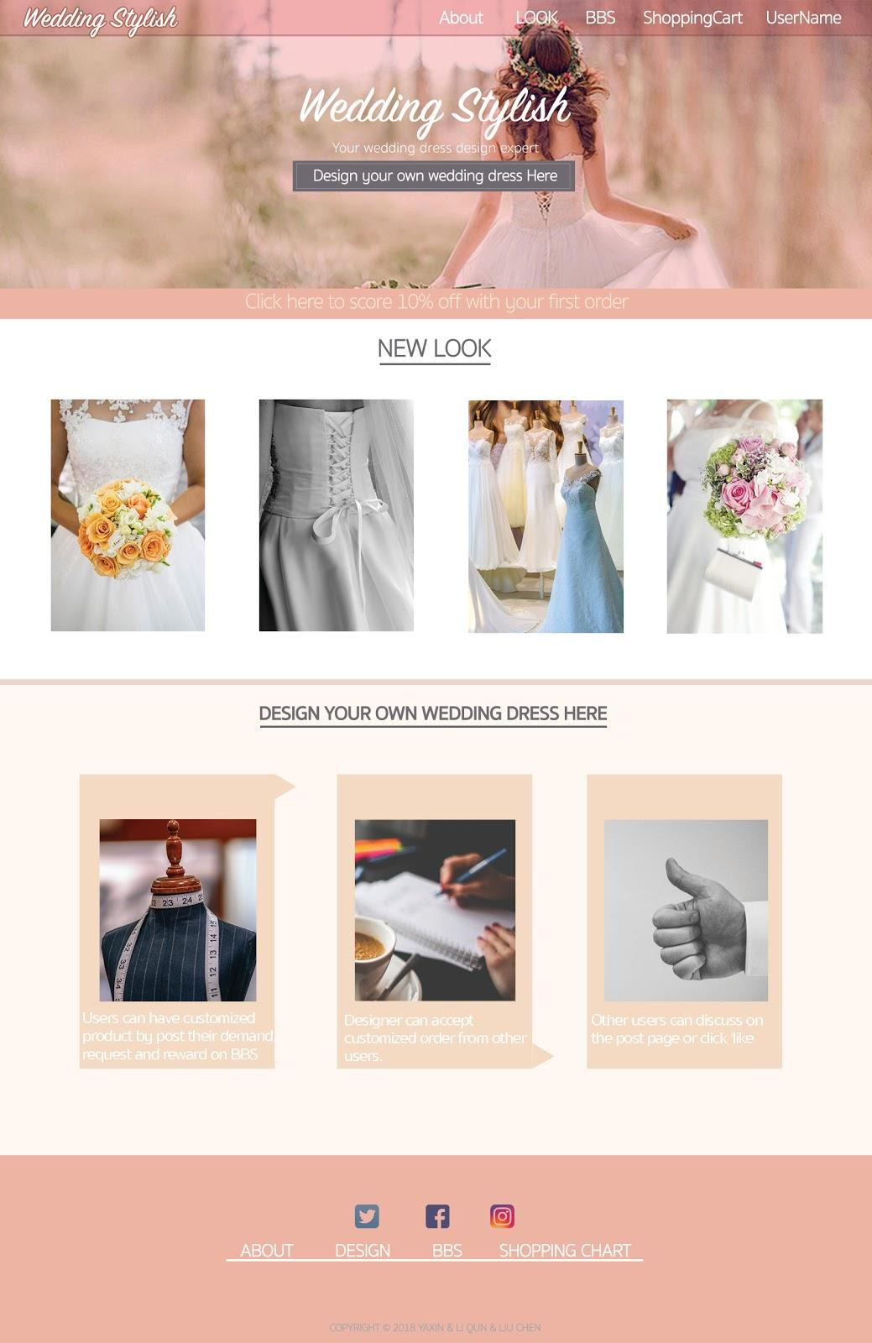

**Colour Theme**

https://lh3.googleusercontent.com/Uv-c6Qy0PyRheaFq1LmzeUAwMp5KuEVExGlbG2gn3h126V4TMshjnV0ZAI-a6VPQV0n3dKTxyFpkwwtfsfmjXLSoH1fWM2hTaYUcmMndO0ilZESv-3Z8KL_7FwTGp6idL7dkx0gn

Low saturation color theme is designed for our website to create a relaxed, clean and pure environment for the user. In the homepage will have an introduction to help user order their own design and it will also display the hot items. The whole UI design is flat which is popular in the modern website design. It just keeps the essential layout to enhance the user experience, reduce the unnecessary steps for shopping.